Final Report

How can the current dashboard be improved to make widget suggestions on relevant information dynamically by filtering and representing data?

Name: Junior Edouard

Student #:516519

School: Inholland University of Applied Science

Company: MM Guide

Date: 08/11/16

Contents

Section A 4

Summary 5

Organization 5

Description of Assignment 7

Main Question 8

Sub-questions 8

Methodology 9

Sub-question 1 9

Sub-question 2 9

Sub-question 3 9

Data Processing and Results 10

Sub-question 1 result: 10

Sub-question 2 results: 13

Sub-question 3 results: 14

Conclusion 18

Discussion 19

References 20

Section B 21

Planning and Approach 22

Assignment Execution 24

Evaluation & Reflection 26

Competence Development (STARR) 27

*1.* *Is able to cooperate effectively within a (project) team.* 27

*2.* *Directs and substantiates the development of personal professional competencies, using input such as feedback and self-reflection.* 27

*3.* *Is able to operate in critical situations in an independent and stress-free manner* 28

*4.* *Is creative and comes up with ideas for solutions.* 28

*5.* *Is able to apply knowledge, insights and skills and transfer these to others.* 29

*6.* *Has the right professional attitude, incorporating relevant moral aspects.* 29

*7.* *Is engaged with his or her job description, quality-focussed, performance-focussed and result -oriented.* 30

# Section A

# Summary

This project was done by Junior Edouard and hosted by the company MM Guide Business Intelligence. The Main objective for this project was to improve an existing dashboard into a Smart dashboard. The smart dashboard allows for use of a client’s database dynamically to filter big data, which selects relevant information about the client’s product or service rendered. The Smart dashboard also monitored the user’s interaction with the dashboard to create a dynamic suggestive system that automatically suggested relevant data that the user was interested in.

This project has been done within a period of 20 weeks, where a working version of the smart dashboard was delivered to the company, including all related information gathered and documents of the project.

# Organization

**MM Guide** is a small company that develops and provides their clients with business intelligence solutions and service for data intensive environments. As an example MM Guide builds data warehouses for their clients, which are used by the client for reporting and data analysis. **MM Guide**, established since 1995, offers are strong in terms of data-quality and data logistics, which translate business related issues into IT solutions to their clients. **MM Guide** has over 15 years of experience in consulting IT service and proprietary solutions and their best quality is to find a perfect balance between process-based work, pragmatism and results.

**MM Guide** is a flat organization that has 29 employees. The company is split into 2 Departments:

* Operations :
  + Human Resources department.
  + Commercial department.
* Projects:
  + Business Analysis
  + Data warehousing
  + Software development
  + Data visualization

At MM Guide the Human resources and commercial departments, which makes up the operations department are responsible for the day-to-day business of the company, which focus on the success of the office.

The projects department is made up of in-house workers (employees that work at the main building of MM guide) and onsite workers (employees that work together with various clients).

Organizational Chart

Figure 1: displaying the Organizational structure of MM guide.

# Description of Assignment

MM Guide (the client) wants a dashboard that will interpret large data sets for future clients through data visualization. The current dashboard system at MM Guide developed for a new proposition business, is a minimal version of a dashboard, when launched has a heatmap functionality implemented on it to display the most popular areas clicked when interacting on the dashboard. The current dashboard has no user interaction, no connection to the database, and no intelligence.

MM Guide would like to improve their current dashboard by:

* Having dynamic information that is being feed from a database.
* Have some widgets that display some information.
* A way to couple big data to structured data in the database.
* Have the widget move dynamically by monitoring user interactions with the dashboard.

# Main Question

How can the current dashboard be improved to make widget suggestions on relevant information dynamically by filtering and representing data?

## Sub-questions

1. How can one measure behavior of user’s interaction with the dashboard?
2. Based on click patterns, how can relevant information be determined and displayed on the dashboard?
3. What technique can be used in filtering the big data on the basis of the structured data?

# Methodology

## Sub-question 1

The current dashboard at MM Guide has been reviewed in order to begin the project. A meeting with the client has taken place to understand what is needed for the improvement of the current system by going over the requirements of the client. The next step was to prepare a literature study on different technical descriptions of software packages that tracked a user’s clicks on a web page. This helped measure user behaviour by interaction with the dashboard. The best method found was implemented and tested.

## Sub-question 2

After the information about the user behaviour was analysed, it has been stored into a table. An algorithm was created to calculate the most clicked areas on the dashboard, which showed how frequently that area was used, and what type of information was presented in that area. An proof of concept a, literature study was also conducted in the best way to present the data collected in a form of suggestive widgets that automatically changed a widget on the dashboard based on user interaction with the smart dashboard.

## Sub-question 3

A literature review on techniques to combine both user structured data and big data. A dummy data base was built using MySQL Workbench to simulate a client’s structured data, by using PHP a connection was made between the database and the dashboard. As proof of concept the information from the database was used in filtering relevant data to be selected from the big data. The information that was produced was then displayed as a graph on the dashboard.

# Data Processing and Results

## Sub-question 1 result:

How can one measure behavior of user’s interaction with the dashboard?

To be able to dynamically move the widgets by monitoring user interactions with the dashboard a literature review was conducted on different methods to measure behavior of a user’s interaction with the dashboard. During the review the following methods were discovered:

* Using a 3rd party monitoring application.

According to Yorish (2016), “*Website monitoring is the process of testing and verifying that end-users can interact with a website or web application as expected*” (Yorish, 2016) and 3Rd party applications such as: Site24x7, Uptime, and Google Analytics, provide such services.

Disadvantage: Although the 3rd party applications can monitor the user interaction on the dashboard, it does not give access to specific information that is needed to register the widgets that were clicked, and the number of times it was clicked, because the information is stored on the 3rd party monitoring application server.

* Implementing a heatmap.

“*Heatmaps are pictures that use color, sound, animation and pattern to organize vast amounts of real time data about multiple financial instruments into a matrix of cells. As Heatmaps receive information, the color and intensity of the individual cells change, indicating a shift in value*” according to Cormac L. Kinney. Angular Heatmap.js is a JavaScript library that can represent the clicks of a user in the form of a colouring scheme that displayed most used area on the dashboard.

Disadvantage: using the previous dashboard to test the heatmap implementation, the information of areas clicked is unattainable because the information is closed source, which according to Wikipedia means “*computer programs whose source code is not published. The source code is not shared with the public for anyone to look at or change.*”

* Create methods using JQuery (JavaScript library)

According to Jquery.com, “*JQuery is a fast, small, and feature-rich JavaScript library. It makes things like HTML document traversal and manipulation, event handling, animation, and Ajax much simpler with an easy-to-use API that works across a multitude of browsers.*” JQuery allows one to write methods that will respond to visitor’s actions on a web page.

Chosen Method:

JQuery was selected as the best method to solve sub-question 1 because the JavaScript library uses event methods, click for example, to trigger or attach a function to an event handler for the selected elements. Using the JavaScript library some functions (shown in figure 2) were created testing the registering of widgets that was clicked on the dashboard and the number of times the widget was clicked on creating a widget table that is stored in the browser’s localstorage shown in figure

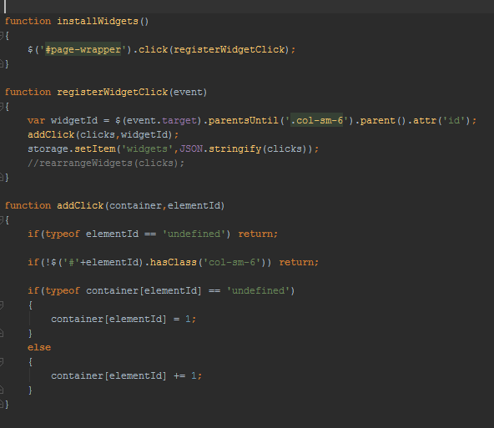

Figure 2: Functions created using JQuery (JavaScript Library)

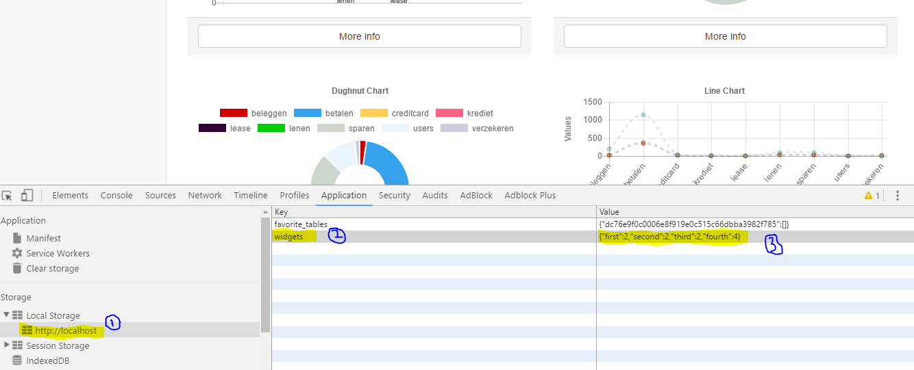

Figure 3. Widget table stored in the local storage of the browser.

## Sub-question 2 results:

Base on click patterns, how can relevant information be determined and displayed on the dashboard?

To be able to determine relevant information base on click patterns, the widget table was analysed and it was determine to sort the widget table by most clicks, which means the information that was displayed on the widget would be deemed relevant. A literature review was conducted on methods to sort the widget table based on most clicks and displaying the widget with the most clicks as the primary widget on the dashboard.

Using the JavaScript language in figure below a function was created to test the sorting of the widget table based on most clicks which are stored in an array of sorted elements.

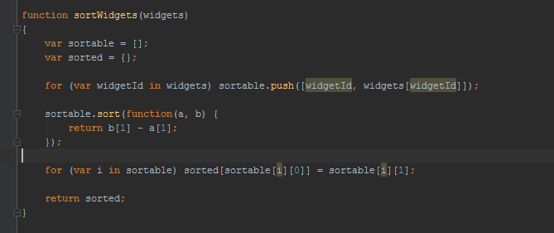

Figure 4 Function created to sort by most clicked widget.

To be able to render the sorted elements array onto the dashboard after the page has been refreshed the JQuery library was used because according to TutorialsPoint, “*DOM manipulation – is made easy by JQuery to select DOM elements, traverse them and modifying their content by using cross-browser open source selector engine called Sizzle*”, making easy to move the widgets dynamically displaying relevant data that is embedded into the widget. In Figure 4 the functionality that was created to rearrange the widgets after the page is refreshed.

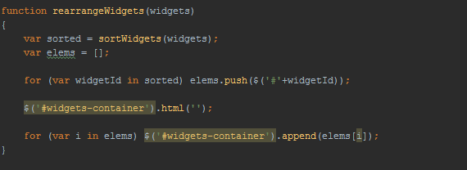

Figure 5. Function created to rearrange Widgets base on sorted Widget table.

## Sub-question 3 results:

What technique can be used in filtering the big-data on the basis of the structured data?

Using MySQL a database was created to simulate the client’s finical structured data. After conducting some research, According to TutorialsPoint,” PHP provides various functions to access MySQL database and to manipulate data records inside MySQL database” and according to Brainvire blogsite “PHP is a server side scripting language it creates dynamic pages with customized features” because of those facts PHP was chosen to connect the database to the dashboard as shown in figure 5 below. A function was written in PHP language that uses SQL statements to access the information from the database shown in figure 6. The function connects to the database and retrieves a list of the tables in the database that will be used for filtering.

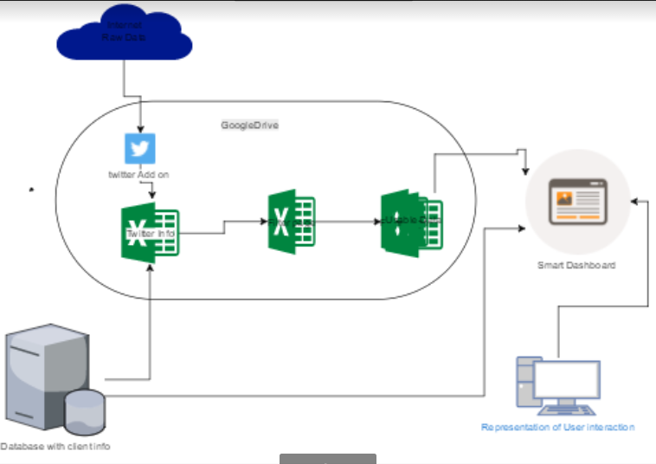

Figure 6. Diagram displaying coupling structure data to the big data.

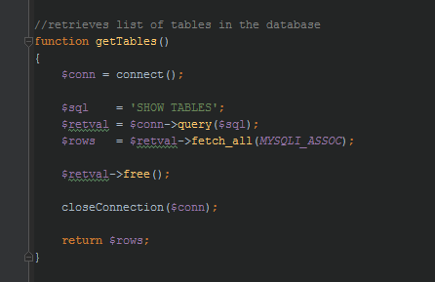

Figure 7. Function written in PHP to retrieve table names from the database.

According to Chris Snijders, Uwe Matzat, Ulf-Dietrich Reips, “Big Data is a loosely defined term used to describe data sets so large and complex that they become awkward to work with using standard statistical software.” The big data will have to be captured and stored. Further research was done on technologies that can capture the big data and store it. The following are results of the research:

* Twitter streaming API: Streams of the public data flowing through twitter. Suitable for following specific users or topics, and data mining.

Disadvantage: A database would have to be created to store the information which is in the form of JSON encoded data structure.

* Twitter Archiver: Twitter Archiver lets you easily save tweets for any search keyword or hashtag in a Google Spreadsheet.

Disadvantage: User will need a twitter account to authorize the Add-on to gather the data and free version limits the amount of search terms that can be used.

Chosen Method:

After discussing the findings with the client it was decided that the Twitter Archiver would be used because it captures the information into the excel sheet which is less time consuming than using the Twitter streaming API, which a database would have to be created to store the JSON structured data.

To combine the structured data and the big data, a literature review was conducted on different methods that can be used connect to Google drive to use the Twitter Archiver as shown in figure 5. The result of the research was PHP Google Sheets API.

PHP Google Sheet API: is a PHP library that gives the developer full control over the content and appearance of the spreadsheet data. By using this API the developer can create methods using the PHP language that can create excel spreadsheet on google drive, create and style individual sheets within the spreadsheet, update individual cells or a batch of cells with values and more.

Advantage: Creating a spreadsheet on google drive will allow the Twitter Archiver plug-in to be used for its function of saving the twitter information that will be filtered by the structured data.

Using the structured data from the database and the Google Sheet API the method in figure 7 was created that would Create the filter sheet for filtering the Big data that was collected using the Twitter Archiver resulting in figure 8, which is an image of the Filter sheet created.

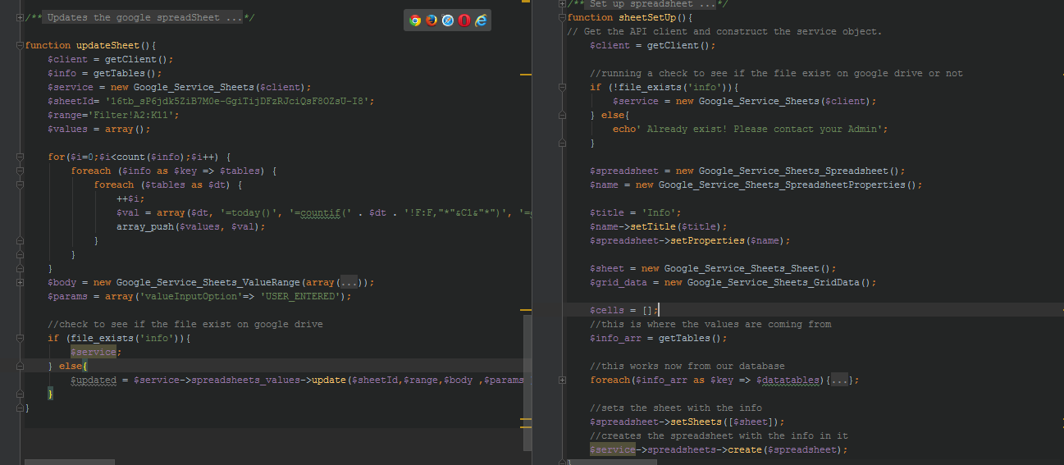

Figure 8. Functions created using PHP google API.

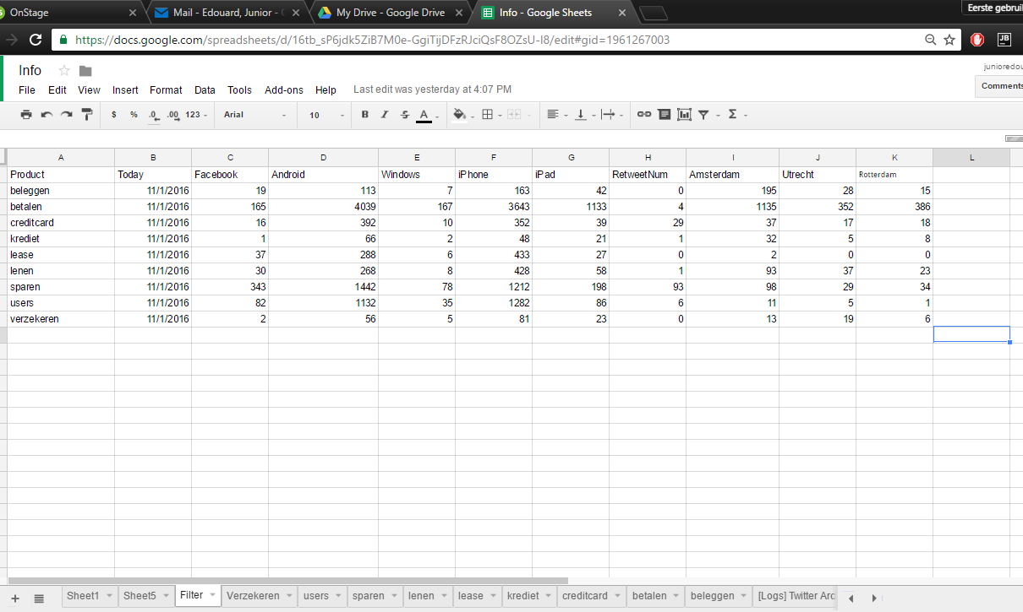

Figure 9. Result of using PHP Google sheets API, Twitter Archiver and the client’s structured data.

# Conclusion

The first sub-question asks how one measure behavior of user’s interaction with the dashboard. By monitoring the user interaction one can identify the most popular widget used. JQuery (JavaScript library) provides event listeners that can be used to set specific functions to listen for an event such as a click, which will then initiate another function. By using this JavaScript library a function was created to register widget id and the number of clicks the widget received creating a widget table to measure the user interaction.

The second sub-question asks how can relevant information be determined and displayed on the dashboard base on click patterns. This sub-question focus on using the click pattern to suggest relevant information to be displayed. After observing the widget table, a JavaScript function was created to sort the widget table in most clicked order, rendering the widget with the relevant information first position on the dashboard to the least relevant information.

The third sub-question asks what technique can be used in filtering the big data on the basis of structure data. Using MySQL a database was created to simulate the clients structured data. Using Twitter archiver, a rule was created to capture the big data set of twitter user tweets and other information. Using the PHP language to access the database, a method was written to extract the table names in the database. The PHP google sheet API was used to create a filter sheet that would use the table names that was extracted from the database to filter the big data that the twitter archiver captured providing relevant information to be displayed on the dashboard.

By answering all 3 sub-questions the pervious dashboard was improved allowing MM Guide future client’s to interpret large data sets through visualization.

# Discussion

The development of the Smart dashboard has enabled the client to:

* Dynamically moving widgets displaying relevant information based on user interaction.
* Couple the structured data and unstructured data to filter relevant information from a big data set.

The Smart dashboard has been built scalable. By doing so there is room for improvement such as:

* Enhance the security For the Smart dashboard.
* Create a page to allow the user to generate Widget with graphs using information of their choosing.

# References

Yorish. (2016).*What is WebSite Monitoring*. Retrieved june 2016. From CIRCID.com: <http://circid.com/blog/ultimate-guide-website-monitoring>

Cornmac L. Kinney (2016). *Heatmaps on Wall Street Visualization Technology for financial Markets has arrived*. Retrieved june2016-october2016. From Wikipedia.org: <https://www.thefreelibrary.com/Heatmaps+on+Wall+Street+Visualization+Technology+for+Financial...-a018648470>

Wikipedia (2016). *Closed source*. Retrieved June 2016. From Wikipedia.org: <https://simple.wikipedia.org/wiki/Closed_source>

Jquery. Jquery. Retrieved July 2016. From Jquery.com: <https://jquery.com>

TutorialsPoint. *DOM Manupluation*. Retrieved August 2016. From TutorialsPoint.com: <https://www.tutorialspoint.com/jquery/jquery-overview.htm>

Brainvire. (2013). What are benefits of using PHP MySQL Development services. Retrieved June 2016. From Brainvire.com: <https://www.brainvire.com/blog/benefits-of-php-mysql-development-services>

Chris ,S., Uwe ,M., Ulf-Dietrch ,R.(2012). “Big Data”: Big Gaps of Knowledge in the Field of Internet Science. Retrieved September 2016. From IJIS.NET: <http://www.ijis.net/ijis7_1/ijis7_1_editorial.pdf>

Ctriq.org(2015). Twitter Archiver. Retrieved June 2016. From Ctriq.org: <http://www.labnol.org/internet/save-twitter-hashtag-tweets/6505>

Mark, Baker, Maarten B., Erik, T.(2009).*PHPExcel*. Retrieved September 2016. From PHPEXCEL.CODEPLEX.COM: <https://phpexcel.codeplex.com>

StalkOverflow.(2016).*Google spreadsheet API*. Retrieved October 2016. From Stalkoverflow.com: <http://stackoverflow.com/tags/google-spreadsheet-api/info>

Jonathan, S.(2015). TableTop. Retrieved October2016. From GitHub.com: <https://github.com/jsoma/tabletop>

Chartjs.(2016).Chartjs. Retrieved August 2016. From Github.com: <https://github.com/chartjs/Chart.js>

# Section B

# Planning and Approach

|  |  |
| --- | --- |
| **Time** | **Activity** |
| Week 1 | * Introduction to the company and employees * Discuss the Internship project with the company’s IT supervisor. * Go over existing Dashboard to review the code. |
| Week 2 | * Research on dashboard * Research on Heat Map implementation * Design front GUI for dashboard * Implement Designs * Write draft project plan |
| Week 3 | * Test basic functionality of dashboard * Implement heat map to dashboard * Update draft project plan. |
| Week 4 | * Conduct meeting between school supervisor,Job supervisor and Myself * Do a literature study on the different techniques used on making the links necessary to connect for transfer of data. * Update project plan |
| Week 5/6 | * Implementing a functional database linked to the dashboard * Update project plan to report |
| Week 7/8 | * Implement algorithm for calculating the pattern of the most clicked areas on the dashboard * Start the Development on suggestive patterns of customer using the information that I have. |
| Week 9/12 | Coupling of the big with structured information to create filter page |
| Week 13 | Continue with the development process |
| Week 14 | Testing Movement of Div with the Sorting algorithm  Brief demonstration of current version of dashboard to School Supervisor. |
| Week 15 | Version 1 of Smart dashboard complete testing. |
| Week 16/17 | Cleaning of Code and set a meeting with the client to discuss possible function to be added to version 1 of Smart dashboard. |
| Week 18 | Organization of the Documentation of the internship |
| Week 19/ 20 | * Presentation to the school supervisor and Job supervisor of the product * Handing in of final product including written documentation of the project. |

# Assignment Execution

|  |  |
| --- | --- |
| **Time** | **Activity** |
| Week 1  1Weeks to complete | * Review of pervious Dashboard system to understand how the dashboard works and what is needed to make it better. |
| Week 2  1 week to Complete | * Design the GUI for the Smart dashboard base on the clients (job supervisor) requirements. * Research on possible templates to use that fits the Design for the Smart dashboard. * Implement a draft dashboard for testing functionalities. * Upload Draft Project plan |
| Week 3  1 week to complete. | * Conduct meeting for the supervisor visit and Upload the minutes to the supervisor meeting to Onstage. * Research on the use of heat map * Implementation of a heat map on draft dashboard to understand how it works. |
| Week 4 /5/6  3 week to complete. | * Update and upload Final project plan to Onstage * Design and Create a dummy database to simulate as the client’s structured data * Populate the database * Link database to the Smart dashboard |
| Week 7/8  2 weeks to complete | * Create an algorithm to measure most clicks for user interaction monitoring. * Implement Sorting algorithm to the measuring algorithm * Implement each algorithm into a JavaScript function to execute both algorithms |
| Week 9/11/12  3 weeks to complete | * Conduct research on coupling structured data to big data. * Connect database to Spreadsheet to retrieve table names from database. * Use table name from database to filter big data using excel formulas |
| Week 13  1 weeks to complete | * Conduct research on what graphs to use to represent the information from the filter sheet to be displayed on the smart dashboard. * Display graphs on smart dashboard using the information from the Filter page on google drive. |
| Week 14  1 week to complete | * Implement movement of the widgets using click table that was created in the previous weeks for user interaction on the smart dashboard. * Complete version 1 of smart dashboard for presentation to school supervisor on One- on-One meeting to discuss project progress. |
| Week 15  1 week for testing  15-20 minutes to complete meeting | * Testing of version 1 of Smart dashboard * Present version 1 Smart dashboard to School supervisor. |
| Week 16/ 17  2 weeks to complete | * Clean code and meet with client to discuss extra functions to be added. |
| Week 18  1 week to complete | * Prepare Presentation and Final Report * Schedule Meeting for presentation of the final product for supervisors. |
| Week 19/20 | * Present the final Product * Submit Presentation   Submit Final report and Final product (Smart Dashboard) |

# Evaluation & Reflection

During the course of this project a couple situations caused for the original planning to be adjusted in order to complete the assignment in the 20 weeks’ time-frame.

* Structure of the planning and execution: During the beginning weeks of the project, a weekly planning was created with the intention to layout each step of the project that had to be executed in a weekly manner, because the planning was not structured correctly some of the end goals for each week were not clearly defined and caused delays when it came to executing some of the tasks planned.

After realizing my problem I approached my job supervisor (Erik Verhoeven) about the problem and he gave me some pointers on laying out the plan in a structure that will prioritized the main functions of the project and breaking them down in to achievable goals set for each week. He also showed me some useful methods to use Excel in creating a well-documented project planning.

* Using Software Packages: With limited knowledge of using software packages /frameworks such as: Bootstrap, TableTop.JS, PHP Google Sheet API and Heatmap Angular.JS, caused a lot of issues throughout the project. The software packages mentioned above was the solutions to some of the problems faced during this assignment, which was why it was so important to have knowledge on how to use them.

To solve this problem a literature study was conducted on each of software package to be used. Some provided enough information on how to use the packages which made it rather simple after but a lot of time was wasted doing this. Another approach I used to solve this problem was to ask my co-workers for assistance with the use of the packages.

By completing this assignment I learned how to prioritize during the process of writing the planning for an efficient and well-time execution of tasks to achieve the end goal of any project for the future. While working at MM Guide also gained knowledge on how to troubleshoot when web developing, how to structure my search terms on Google for better search results and different tactics for solving a problem. I enjoyed my time at MM Guide.

# Competence Development (STARR)

## Is able to cooperate effectively within a (project) team.

**Situation:** During my 5th week at MM Guide my co-worker was testing a function he wrote for a VR (virtual Reality) game he was working on. Everyone was busy with other task they had to complete for the day and he needed someone to test the functionality using the VR headset while he monitored the response on his pc.

**Task:** I was to put on the VR headset and follow his instructions and push a couple buttons when he requested.

**Action:** I put on the VR headset and followed instructions as instructed.

**Results:** During his test he found some bugs within the code that wasn’t responding like he wanted, which he caught on time before moving on to another assignment for the day.

**Reflection:** Testing code amongst members in a team is important because it gives one the opportunity to catch a mistake before the code goes to production, and it also gives you an opportunity to get different opinions and suggestions base off of the group’s feedback.

## Directs and substantiates the development of personal professional competencies, using input such as feedback and self-reflection.

**Situation:** After working at MM Guide for a couple weeks on my project, I was approached by my Job supervisor about my planning of the project. He was concerned that I was not structuring the planning correctly, therefore making it difficult to achieving the goal of the project.

**Task:** Plan each steps of the projects in a weekly manner, outline what is to be done each week to meet the deadlines in creating a working version of the smart dashboard to be presented to the Job supervisor.

**Action:** I set a meeting with my Job supervisor, where I asked him to assist me in writing a structured project plan that would aid me in achieving my goal that was set at the end of the project.

**Results:** Implementing each step of the project became simpler. By dedicating each phase of the project to a week made the scope of the project more achievable.

**Reflection:** During this project I learned that a well-structured planning can make the difference on how smooth a project or assignment can go. Thanks to the feedback of my Job supervisor I was able to create a better structured planning.

## Is able to operate in critical situations in an independent and stress-free manner

**Situation**: At the start of the internship I started with limited knowledge of using software frameworks in a project, causing a delay in my planning. I was put in a position where I had to apply myself by doing research on how to use certain framework (e.g. Bootstrap 3), to be able to move forward in my project.

**Task:** I was to build a template dashboard, for testing, using Bootstrap 3 and the time frame was set to 1 week to get complete because of lack of knowledge an extra week was added to time frame.

**Action:** I did some research on the use of Bootstrap. After which I followed a few tutorials on the subject to familiarize myself with the Framework.

**Results:** After a couple of days of research and self-implementation that took almost 2 weeks, I was able to create a simple template which I used throughout the project to test some functionalities that was to be implemented into the final product of the project.

**Reflection:** Although I wasn’t fully after that week I was able to make use of some frameworks in the basic form to start things off. I am more comfortable working with the Bootstrap 3 framework to achieve any goal I need to use it for.

## Is creative and comes up with ideas for solutions.

**Situation:** The Smart dashboard system that was created during this project has a very important functionality that monitors the users clicking actions and stores them to be used later to sort some widgets that are displayed on the smart dashboard. An issue was how to store the user clicks for later use.

**Task:** Store the user clicks and the elements id they clicked on to be able to sort the widgets base on those clicks made before.

**Action:** After doing some research on different ways that the click information can be stored 1 solution was to save the information in a cookie. During a meeting with the client (Job supervisor), to discuss the solution found, it was pointed out using a cookie would allow the user of the dashboard access to delete the cookie which can cause an issue with sorting the widgets. After a few trails and no success, I did some more research and came up with a different solution to the problem, Use the local storage that is provided by the browser.

**Results:** The clicks and their element Id’s were saveable and the information can be accessed at any time and the user of the dashboard has no way of deleting that information.

**Reflection:** During this assignment I learned that there is never one way of doing things. Other options exist you just have to apply yourself and set your mind to finding a solution that works for the type of problem that needs to be solved.

## Is able to apply knowledge, insights and skills and transfer these to others.

**Situation:** After meeting with the client (Job supervisor) at MM Guide, I was to write up some possible functionality that might be needed to implement into the Smart dashboard base off of the previous dashboard.

**Task:** Study the pervious dashboard to understand how it functions. Then create a short list of some requirements that will improve on the previous dashboard to make the Smart dashboard better base on pervious dashboard and meeting with the client.

**Action:** Analyse the code in the old dashboard. Test the functionalities found to better understand how it works.

**Results:** I understood how the dashboard works and was able to create a short list of things that will improve the pervious dashboard to make it into a smart dashboard, which allowed me to create a project planning for the project, and also allow me to be able to explain how the smart dashboard will work after it is complete to others.

**Reflection:** Doing this assignment taught me that reading code takes some time and how easier it is to read another person’s code when the documentation is also present but if one takes their time and read each line the code can be understandable and editable.

## Has the right professional attitude, incorporating relevant moral aspects.

**Situation:** During my internship I was faced with a very difficult issue concerning the coupling part of the project. The table Names from the clients database, were not able to print to an excel sheet that was located on google drive. After a few attempts I decided that it would be wise to ask one of my co-workers for assistance in the matter because they have more experience coding and would most-likely know the solution to the problem but they all were in a meeting for the day and I needed that part of the project complete before the new week starts.

**Task:** Print out table Names from clients database to google spreadsheet.

**Action:** I decided to work on a different assignment while I patiently waited for my co-worker to end their meeting.

**Results:** After the meeting was over, I approached one of my co-workers with the issues and they assisted me in the matter.as a result of this I was able to complete the assignment for the week and I was able to print the table names to the spreadsheet.

**Reflection:** During this assignment I learn being patient when faced with an issue is the best approach and communication amongst co-workers is one of the benefiting factors of a successful business because team work is what got the assignment completed.

## Is engaged with his or her job description, quality-focussed, performance-focussed and result -oriented.

**Situation:** The client (Job supervisor) at MM Guide wanted to be able to view what tables they have on their database that represents their structured data. The dashboard that existed before this internship project was populated with static information that was embedded into the dashboard.

**Task:** Create a database to store the client’s information on their services provided. Display the tables and the information stored in each table in the database onto the Smart dashboard.

**Action:** A meeting was set with the client, were we discussed the design of the database model. After the meeting a sketch of the database was created and discussed with the client. The database was created and populated accordingly. Using the knowledge taught to me in school I used the PHP language to get the information from the database and displayed it on the smart dashboard.

Using a JQuery plug-in called “DataTables” I manage to give the tables displayed on the dashboard a better look for the user.

**Results:** Because of my of my hard work on this assignment, the client can now see all the information on their database easily from the smart dashboard. They are also able to do small searches on the tables, filter and even sort the tables like they were in the database themselves without the knowledge of the database syntax, thanks to the JQuery plug-in that was also implemented.

**Reflection:** This task gave me the opportunity to freshen up on my database skills and learn a new way to structure a database, gain experience using MySQL workbench and also learn a new JQuery plug-in to use when it comes to representing the tables on a website.